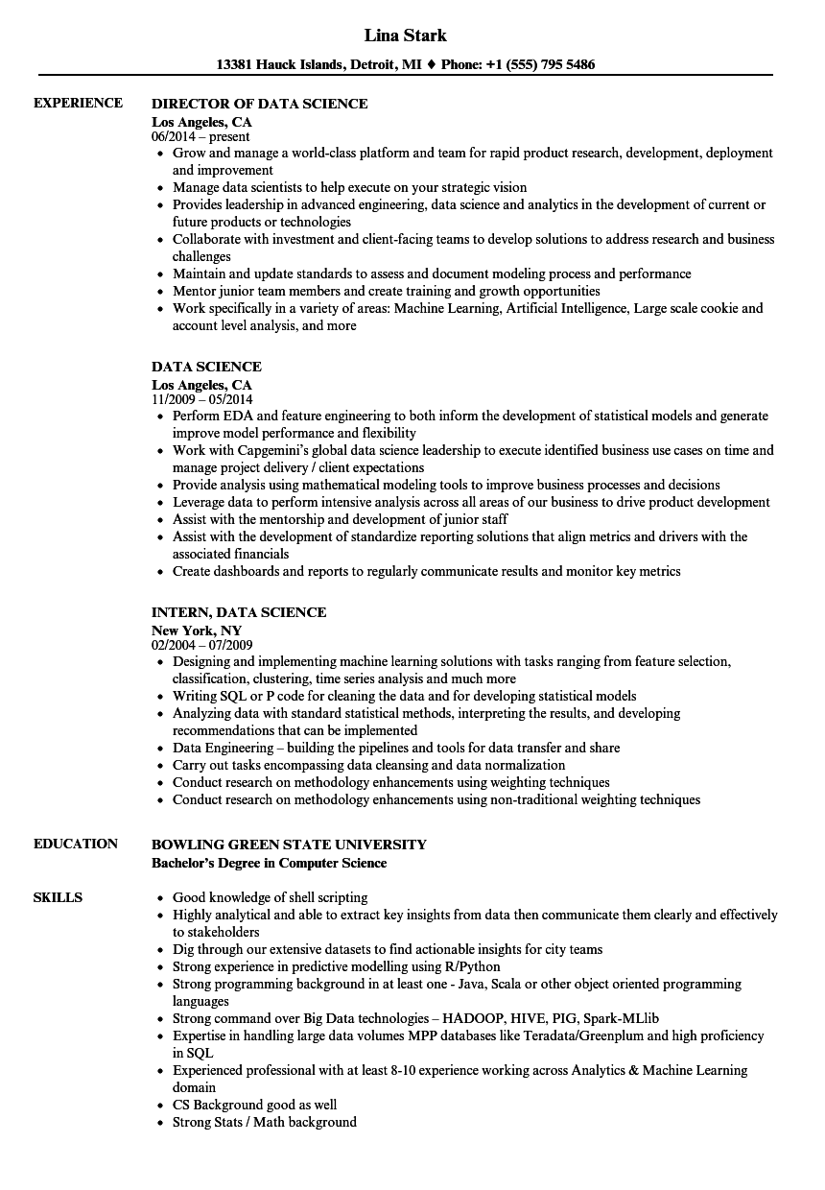
EXPERIENCE
EDUCATION
SKILLS
Lina Stark
13381 Hauck Islands, Detroit, MI ♦ Phone: +1 (555) 795 5486
DIRECTOR OF DATA SCIENCE
Los Angeles, CA
06/2014-present
• Grow and manage a world-class platform and team for rapid product research, development, deployment and improvement
• Manage data scientists to help execute on your strategic vision
• Provides leadership in advanced engineering, data science and analytics in the development of current or future products or technologies
• Collaborate with investment and client-facing teams to develop solutions to address research and business challenges
• Maintain and update standards to assess and document modeling process and performance
• Mentor junior team members and create training and growth opportunities
• Work specifically in a variety of areas: Machine Learning, Artificial Intelligence, Large scale cookie and account level analysis, and more
DATA SCIENCE
Los Angeles, CA
11/2009 - 05/2014
• Perform EDA and feature engineering to both inform the development of statistical models and generate improve model performance and flexibility
• Work with Capgemini's global data science leadership to execute identified business use cases on time and manage project delivery / client expectations
• Provide analysis using mathematical modeling tools to improve business processes and decisions
• Leverage data to perform intensive analysis across all areas of our business to drive product development • Assist with the mentorship and development of junior staff
• Assist with the development of standardize reporting solutions that align metrics and drivers with the associated financials
• Create dashboards and reports to regularly communicate results and monitor key metrics
INTERN, DATA SCIENCE
New York, NY
02/2004-07/2009
• Designing and implementing machine learning solutions with tasks ranging from feature selection, classification, clustering, time series analysis and much more
• Writing SQL or P code for cleaning the data and for developing statistical models
• Analyzing data with standard statistical methods, interpreting the results, and developing recommendations that can be implemented
⚫ Data Engineering - building the pipelines and tools for data transfer and share
• Carry out tasks encompassing data cleansing and data normalization
• Conduct research on methodology enhancements using weighting techniques
• Conduct research on methodology enhancements using non-traditional weighting techniques
BOWLING GREEN STATE UNIVERSITY
Bachelor's Degree in Computer Science
• Good knowledge of shell scripting
• Highly analytical and able to extract key insights from data then communicate them clearly and effectively to stakeholders
• Dig through our extensive datasets to find actionable insights for city teams
• Strong experience in predictive modelling using R/Python
• Strong programming background in at least one - Java, Scala or other object oriented programming languages
• Strong command over Big Data technologies – HADOOP, HIVE, PIG, Spark-MLlib
• Expertise in handling large data volumes MPP databases like Teradata/Greenplum and high proficiency in SQL
• Experienced professional with at least 8-10 experience working across Analytics & Machine Learning domain
⚫ CS Background good as well
• Strong Stats / Math background

